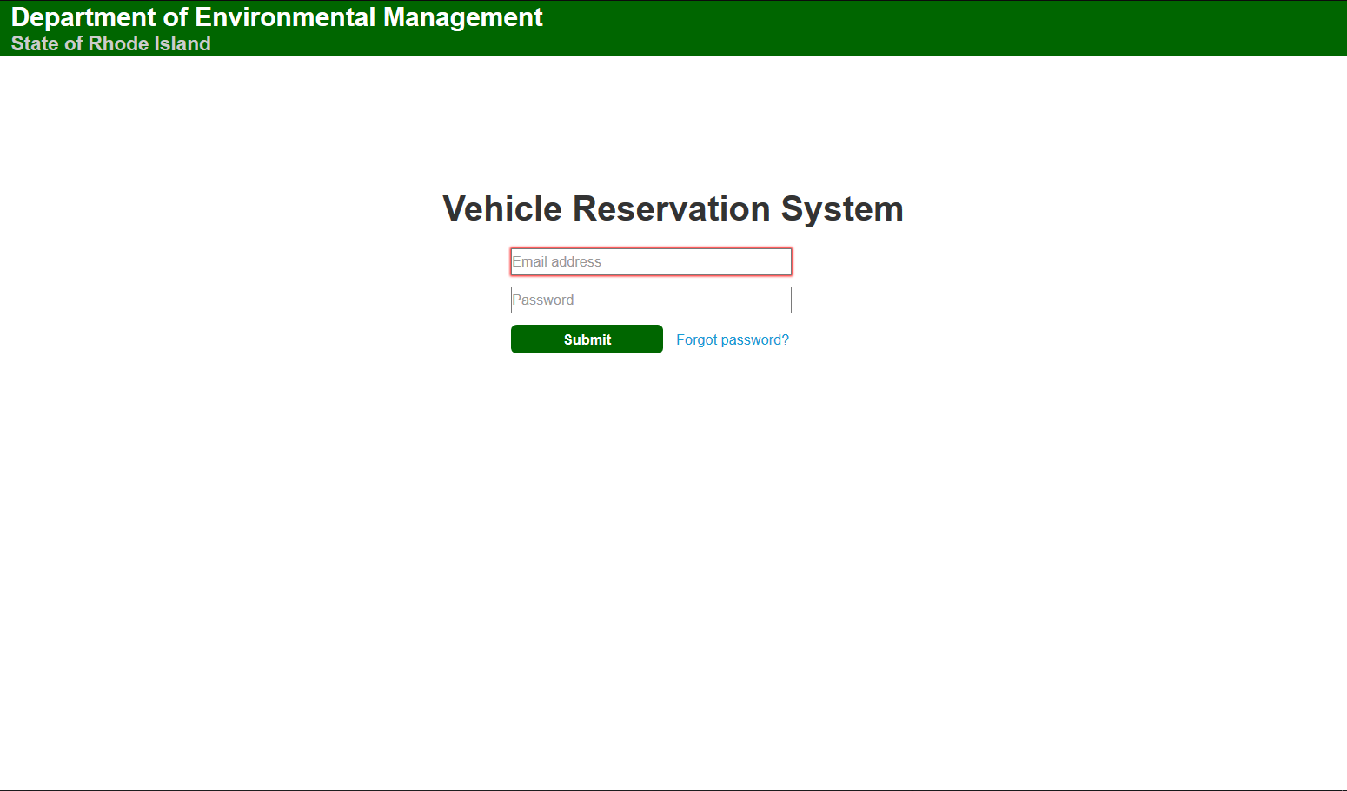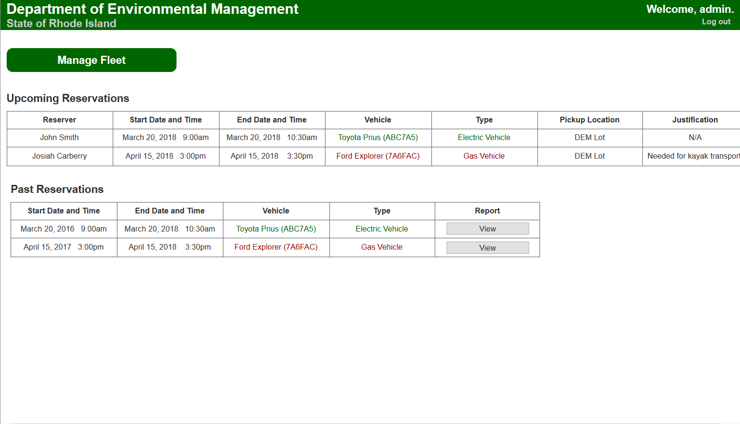

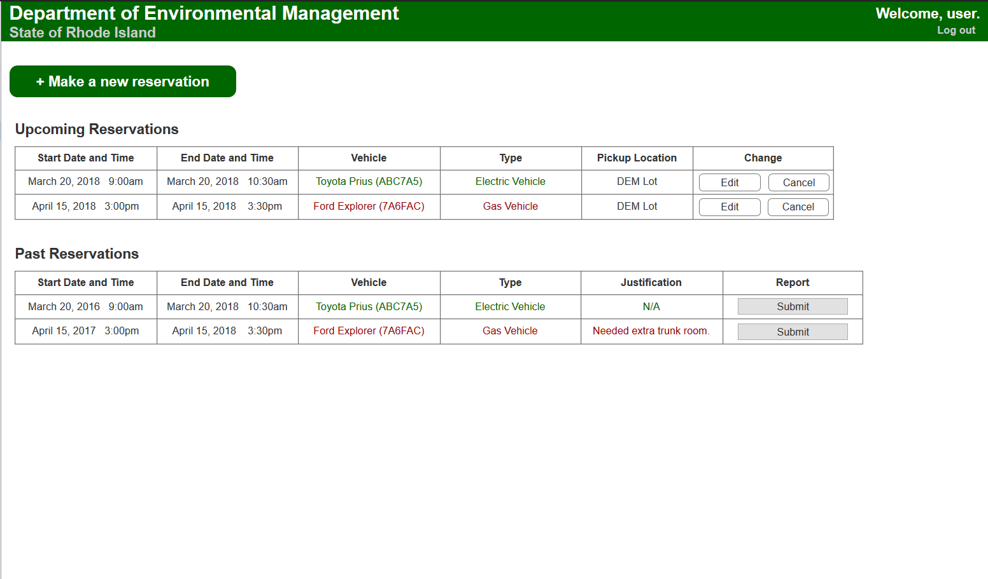

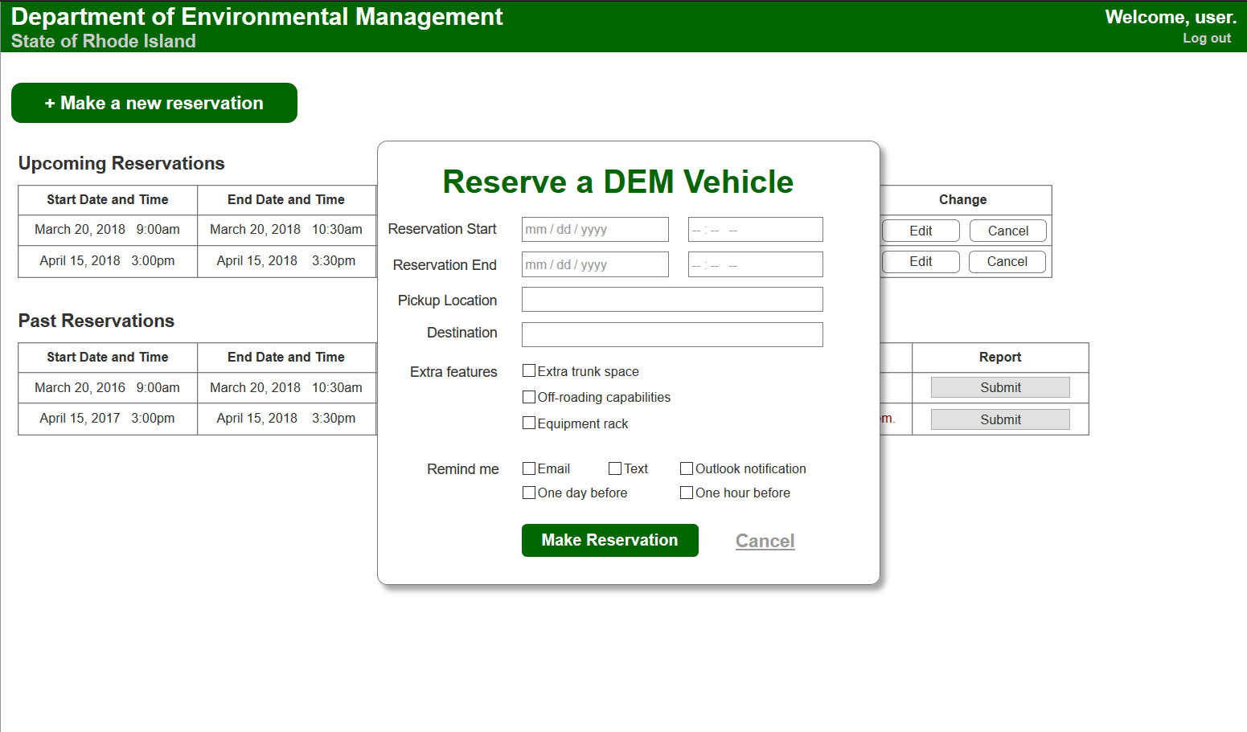

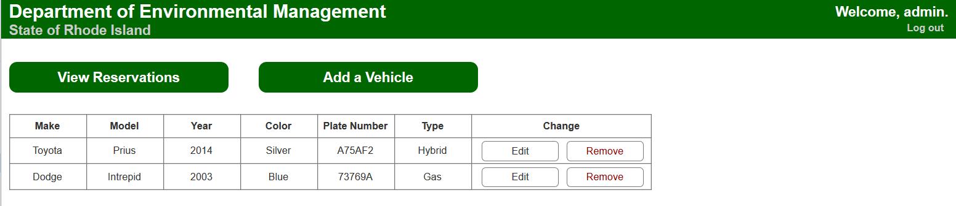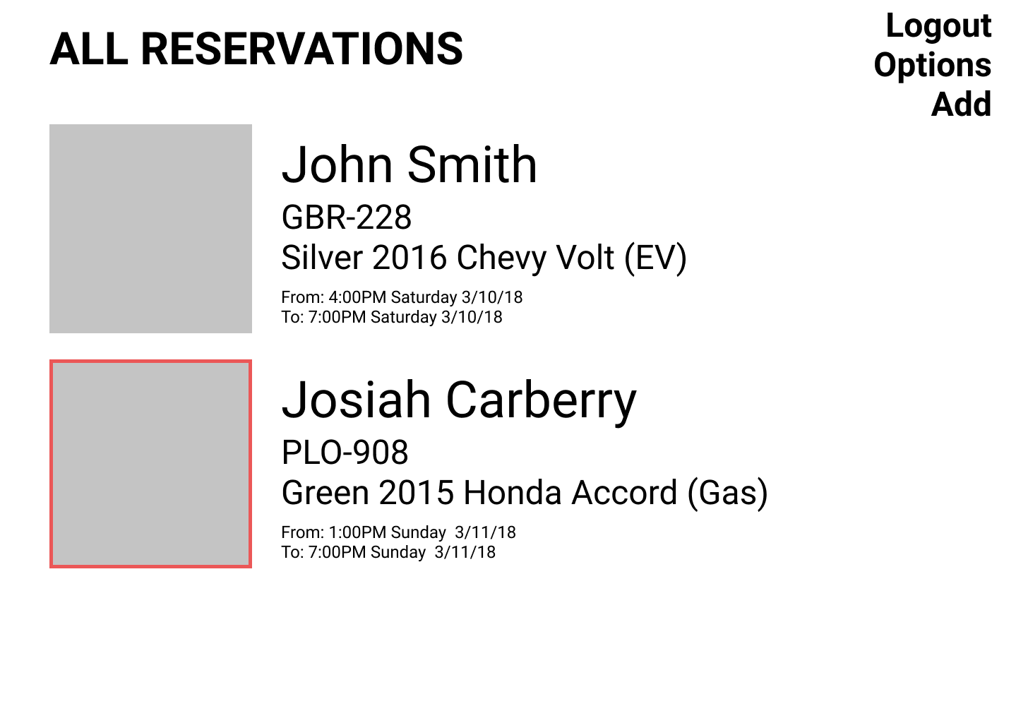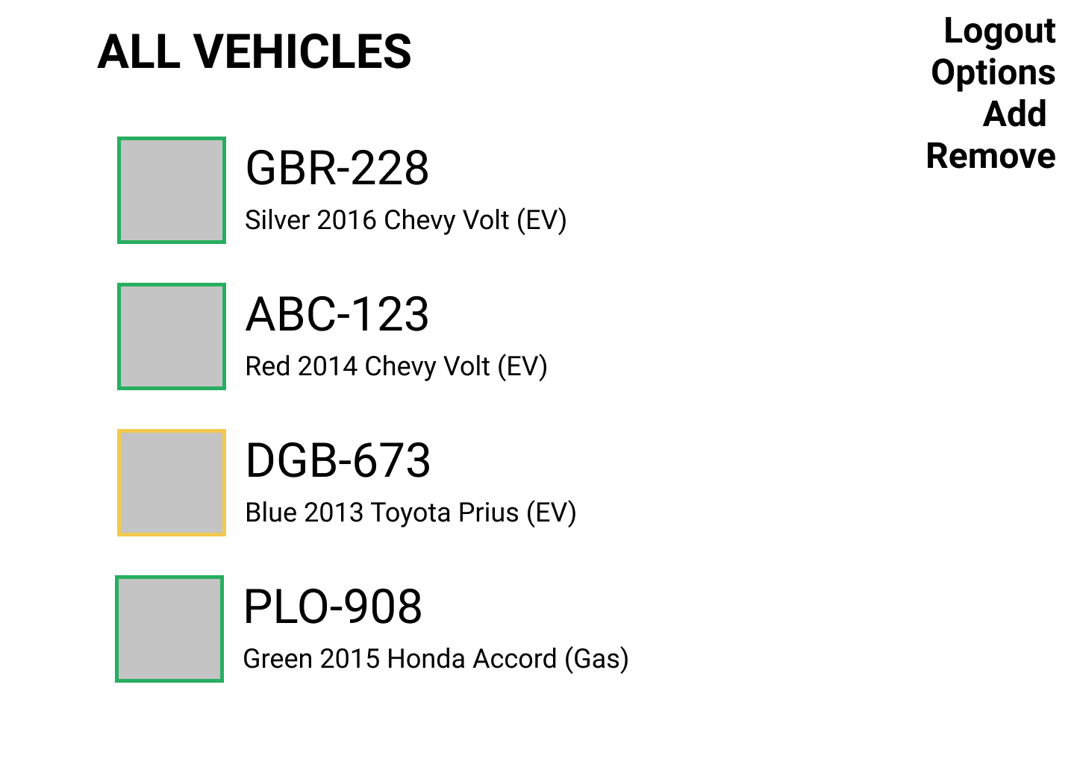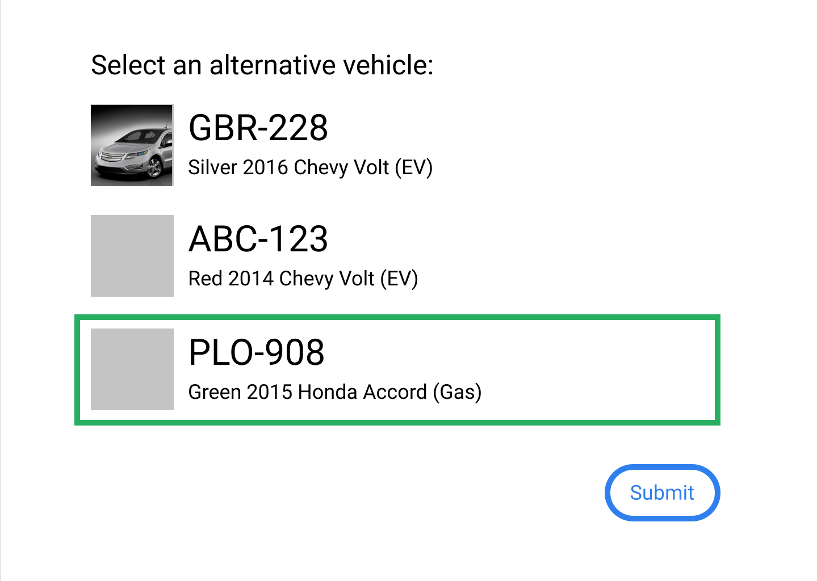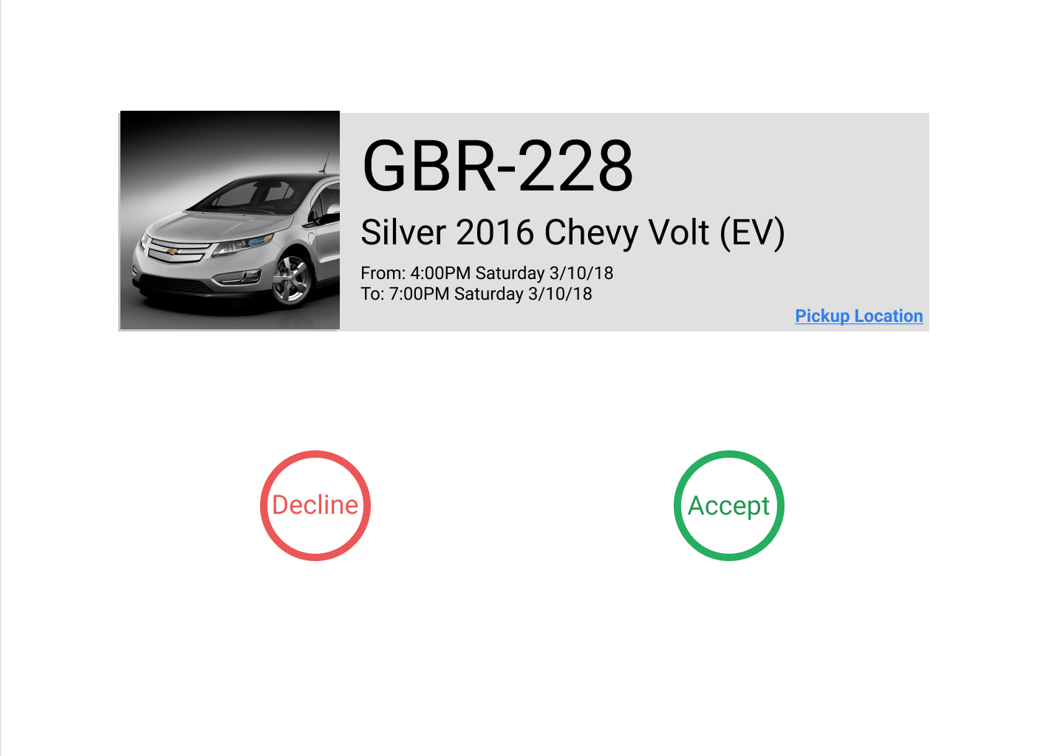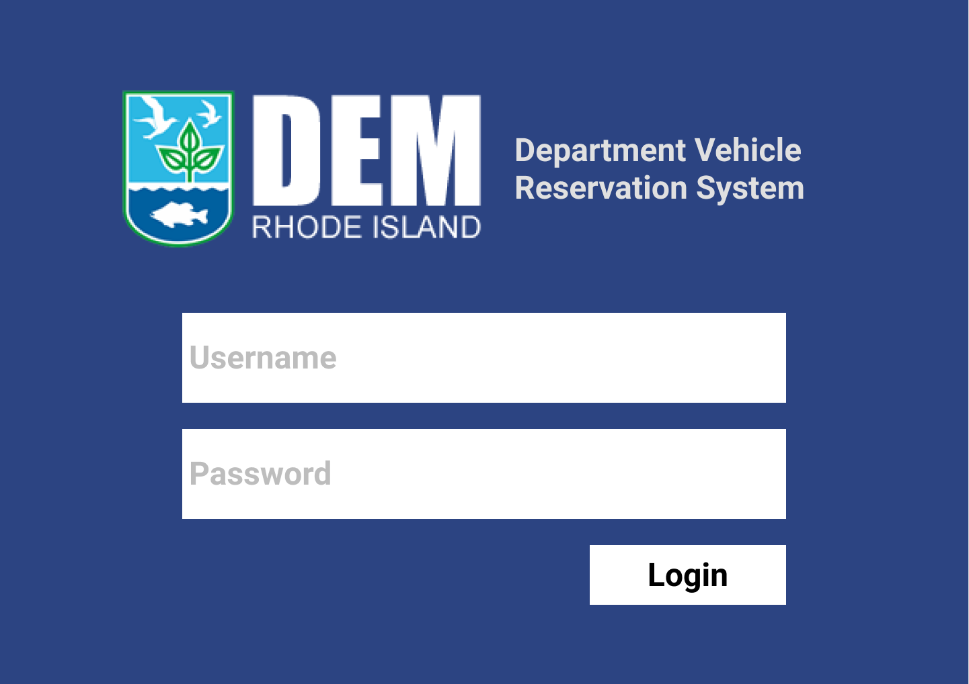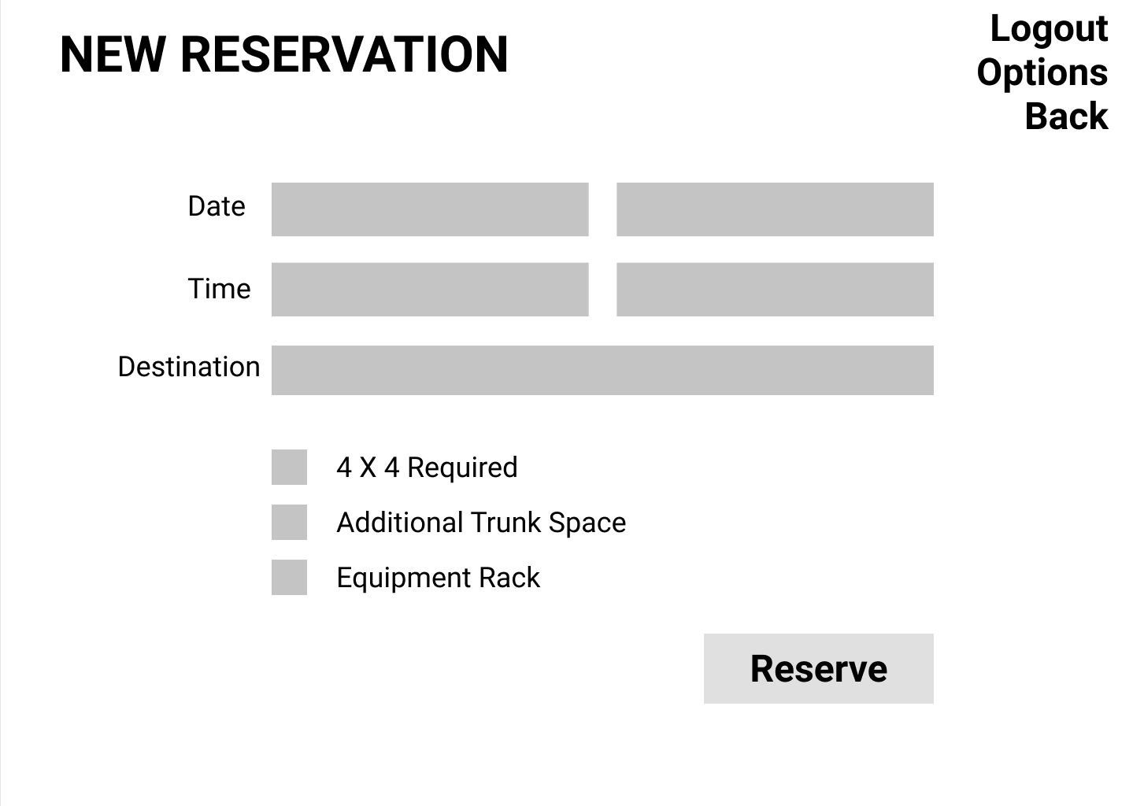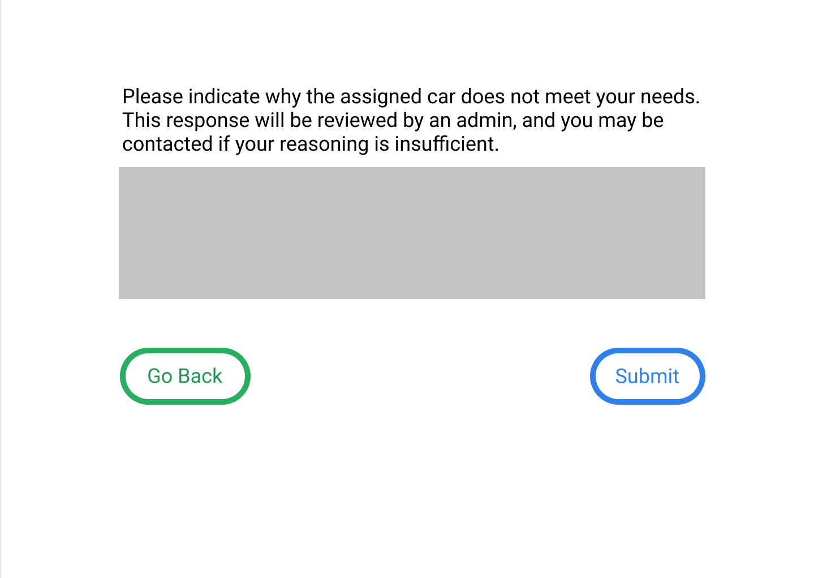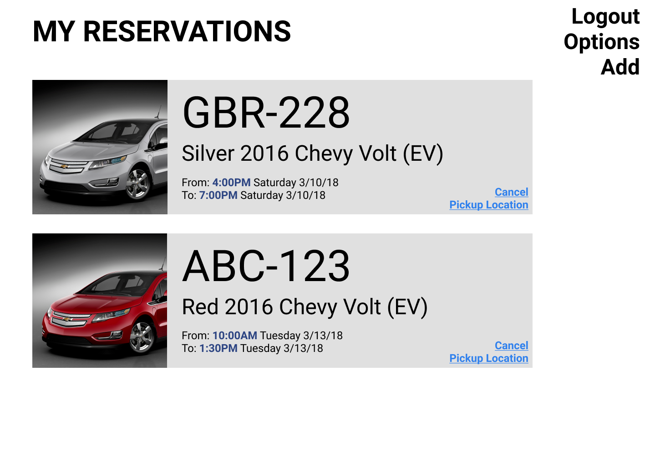

**Electric Car Reservation System**

Department of Environmental Management

**Goals:**

* Encourage the usage of electric vehicles.
  + Make it opt-out vs opt-in
* Make the system easy to use.
* Allow admins to manage the fleet.
* Collect useful data for DEM.
* Potentially create educational pages to dispel fears of electric vehicles.

**Useful Statistics:**

* 3 electric vehicles used equals 98 kg greenhouse gas / day.
* Equivalently, that’s 36 gallons of gasoline.
* That would be ***1640 kg***of greenhouse gases / year.

Project Specifications:

**All Users:**

* Create account and log in
* Restrict to users with specific email domain

**Admin User:**

* Manage fleet (add/delete vehicles)
  + Take vehicles out for service
* View feedback about vehicle condition
  + Get emails when feedback added
* See / export collected vehicle data

**End User:**

* Make a reservation
  + Pick-up location, destination, time length
  + Integrate with Google Maps API for distance/time
  + EV option is presented first- make it more difficult to use gas
* View/edit existing reservation
  + Cancel if needed
  + See user information
* Get reminded about reservation
  + Via email and/or text
  + After reservation
  + Prompt for feedback